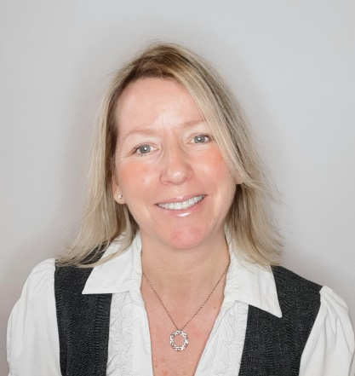
Sherri Palle MBA, CPCA
Business Advisor & Coach
“I help the entire team connect the dots and make sense of the complex world in which they operate – so they can gain control, coordinate their efforts, exceed client expectations, embrace automation, achieve their goals, reduce stress, and restore the passion and enthusiasm for what they do.”

Sherri is fervently committed to helping financial professionals either fine-tune or completely reengineer their advisory practice to create success by systematizing and growing their practice. She will become fully entrenched in your business to provide the best advice possible. She is known for her high-energy calls which provide motivation, enthusiasm, and thought provoking ‘aha moments’ – making these calls something the entire team looks forward to.
Sherri began working as a Business Coach at Pareto Systems in 2005 where she worked with financial advisory teams all over North America and continues to work in collaboration with Pareto Systems today. In 2014 she co-founded Mindset Consulting allowing her to work extensively with an exclusive group of advisory teams. During her 16 years of coaching, she’s had the opportunity to develop and deliver customized training programs for several reputable, successful financial firms throughout North America.
Previously, Sherri spent nine years working directly in the financial services industry where she naturally gravitated to developing systems and process – to create order and quality control for all aspects of the client experience. This is in fact, where she was introduced to coaching via Pareto Systems in 2002 – 17 years ago. Combined, her direct industry knowledge and coaching experience provide her with 24 years of unique insight, which puts her in a solid position to help teams fully implement a results-driven process.
Education
- Master of Business Administration (MBA – Entrepreneurism & HR) University of Victoria, Victoria BC.
- Bachelor of Commerce (Marketing) Mount Allison University, Sackville NB.
- Canadian Securities Course (CSC) and Conduct & Practices (CPH)
- Professional Financial Planner (PFP)
- Certified Professional Consultant on Aging (CPCA®)
- Certification in Life Coaching & Mindfulness and Reiki Mastery

More about Sherri
Sherri lives in the sea-side town of Sooke on Vancouver Island, British Columbia. She enjoys keeping busy with her children: Ayden, Ethan and Samantha. This includes supporting their increased independence as they move from teenagers to young adults, as well as volunteering with them for various school, sport & community initiatives. Personally, she thoroughly enjoys keeping fit by walking daily with her favorite tunes (#Fleetwood Mac). She also likes to read self-help and business books, but will occasionally indulge in a great rock concert. Sherri’s life has been personally affected by Autism and she has fully embraced advocating for this cause. She is a member of the BC Autism Society and the President & Founder of the Sooke Autism Support System (SASS).
Favorite Words to Live By: “If you love your job, you’ll never work a day in your life.”

