

June 2023 Edition #47

ACE & THE MID-YEAR POINT

Well, here we are into June and quickly approaching the Mid-Point of 2023. WOW – this year is flying by so quickly.

The PSA Process

A reminder to reflect on the areas related to your ACE Summary where you’d like to achieve additional improvement this year. This of course, varies from advisor to advisor. With that, there are also a number of circumstances each wealth advisory team is managing in conjunction with the desire to organize and grow their advisory practice. Identify the most important area to you and make it a focus area for the rest of 2023.

Financial Planning

The newest ACE component measured in Part 2 focuses on bring your high value clients financial plans is of critical importance -- many of these individuals are millionaires or close to it.

Planning is not an option – especially when it comes to helping them minimize taxes during retirement as well as, Estate Planning. The general guideline for Financial Plans at CUSO is approximately 24 being created and/or updated for top clients each year (assuming you have at least 24 top tier clients in your advisory book). This works out to an average of 2 clients per month. This is a great time to see where you are at in relation to this.

UPCOMING WEBINAR EVENT – Insurance

Please join Aviso for a session with Stephen Belch, Regional Insurance Consultant at Aviso Wealth as he walks through how to conduct a large insurance case.

Understand his approach and the steps he took to uncover the opportunity and close the business.

Date: June 22, 2023 at 9am PT / 10am MT

Please register in advance at https://us06web.zoom.us/meeting/register/tZApfu-qqj4pEtX0WJZDn8xjwIrry_8yKsEt

COMFORT ZONE CAUTION
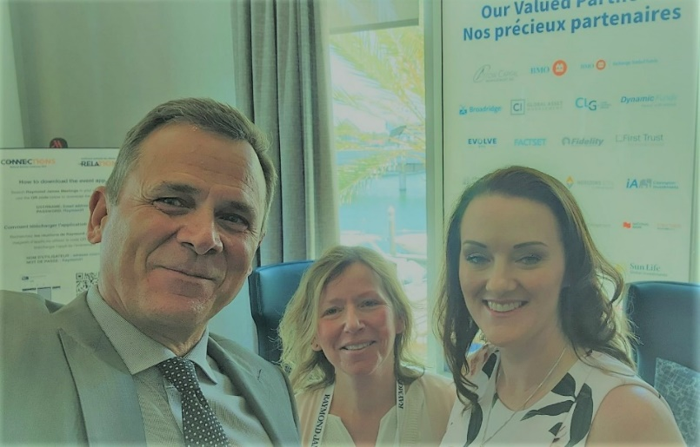
You know I always say I will never ask you to do something I, myself am not prepared to do. I also know that my role is about supporting financial professionals as it relates to everything they are already doing well AND nudging them outside of their comfort zone at times so they can experience meaningful professional growth. This is my story of choosing to go outside the comfort zone.

A few weeks back I was a Guest Speaker at the Raymond James National Business Conference in Tampa, Florida. When I originally received the invitation, my first thought was all the reasons why I couldn’t go – I am too busy, it would be extra work, that long, long flight -- this is the fear kicking in (fight or flight instinct) but at least I’m aware of it so I can pause and reflect more carefully about this incredible opportunity. I worked through my initial fears and accepted the invitation – that was many months ago and honestly, although it was in the back of my mind, I didn’t pay it a whole lot of attention. I just kept doing my thing.

Flash forward to the month leading up to the event and it brought a few sleepless nights and a bit of additional stress – yes, I was getting increasingly ‘uncomfortable’. As I was preparing to make the very looooooong flight to Florida on May 2nd I was remaining positive and focusing how this IS important and I will get to meet new people and learn new things – as well as share my knowledge with others. Now, it’s May 4th and it’s show time. This is the day I have two Guest Speaking sessions with the most accomplished advisors at Raymond James where registration was restricted to their top producers and largest teams. Full disclosure: Now I feel sick to my stomach. Who am I to share my wisdom? What could I possibly offer? How can I help these hugely successful teams? Fear & Self-Doubt kicking into high gear. I ask myself why did I agree to do this? Next, I envision what it would be like to be at home – ah so nice – I would be drinking by beloved morning tea in my favourite mug, in my cozy office looking out my big window and feeling absolutely comfortable. Exhale. But instead, I’m here!

I get to the venue early so I can get set up and become acquainted with the layout and how it will all work. They want me to wear a mic but I assure them, I can project! Here comes the first few advisors and I introduce myself and get to know more about them. Then a few more and a few more. Next I know, Andrea Linger, VP Practice Management Raymond James (next to me in the photo) has people asking to come in – they tried to register, but it was full. She accommodates as many people as she can based on who can fit in the room and then at one point, she has to turn Advisors away and shut the door. We are at maximum capacity. Wow – talk about pressure.

Here’s where the story takes a wonderful turn – I take a deep breath, tell myself “I’ve got this”, then I just start talking about what I know they are there to hear. I’m in the zone. I’m having FUN. They are so engaged. I barely notice the guy walking around the room with a big camera recording me the entire time. The session ends, there is a lunch break and here I go for round 2. The first thing I notice for the second session and topic is everyone came back! Well, that’s a great sign : ) It was lather, rinse, repeat and I had a GREAT time. I was so glad that I pushed through the fear and the excuses and just made it happen. I also got to meet Duncan MacPherson, CEO Pareto Systems (also in the photo) for the first time in person – and we’ve been working together collaboratively for nearly 20 years.

Moral of the Story: Exciting Opportunities Live On The Other Side of Our Comfort Zone.

#OvercomeFear #BelieveInYourself #JustDoIt

CUSO SHOUT OUTS!

We want to give a big SHOUT OUT to David VB from CCU for letting his clients, prospects and strategic partners know about his ongoing commitment to excellence. David recently sent out an email communication to let them know about his participation in the Certified Professional Consultant on Aging (CPCA)® designation. What a great opportunity to reach out to your network to demonstrate how you continue to invest in providing great service – specifically to an aging demographic. Please see below for a sample of what David sent out:

Dear Friends,

Every so often a training opportunity becomes available that can truly make a difference in the way that services are offered in our community. I recently signed up for a program offered by Age-Friendly Business®, to earn the Certified Professional Consultant on Aging (CPCA)® designation.

This course introduces some of the health, social, legal, and financial issues facing a maturing population, and identifies how financial planning professionals can provide even more relevant service. From trends in aging, to care giving, housing, retirement, estate planning, and so much more. I am looking forward to learning more about what is important as we move through various life stages and transitions, and what our community wants from the professionals who serve them. I know that this information will help me provide an even better client experience for all those who clearly deserve nothing less.

Stay tuned for a future announcement letter later this year when I finish my training and become our community’s next Certified Professional Consultant on Aging (CPCA)®!

If you’re interest in learning more - https://www.cpcacanada.com/

Warmly,

We also want to give another coaching SHOUT OUT to Bobbi from LCU who recently delivered a PFO binder and Moment of Truth to the same A client. Since then, this top client has referred Bobbi some clients and gave her very positive feedback on the Aviso client survey. When they were asked, “Would you refer your advisor? There answer was “Yes, and I am actively referring her.” What a beautiful example of cause and effect!

MORE PARTNER-BRANDED RESOURCES!

We’ve recently added even more partner-branded items to the CUSO Magical Portal – this includes Agendas used for the following:

- Client Rebranding – Financial Planners
- Client Transition – MFIS
- Review Meeting Agendas – Financial Planners & MFIS

You can access all of these items in the CUSO Magical Portal in a section called PSA Special Sessions & Resources à Branded Packages à Click on your Partner Logo to access a variety of branded and client-friendly PSA resources for Financial Planners & MFIS. They are all in a WORD format so you can edit and modify them as you see fit.
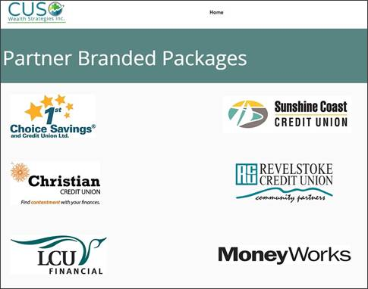

BOOMER BANTER – WHAT YOU NEED TO KNOW

A few weeks ago, I received a terrific email from a CUSO Advisor about how to help their Boomer Clients prepare for retirement beyond the money aspect and it read like this:
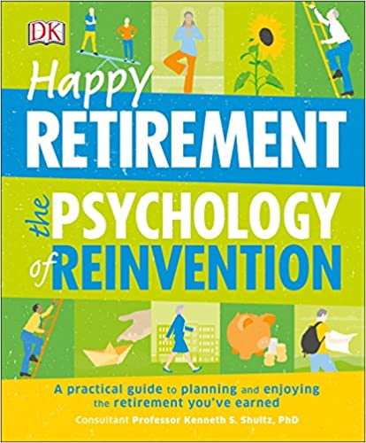
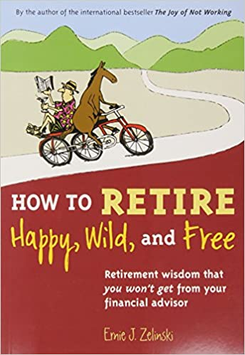
One topic I usually bring up with clients nearing retirement is the less talked about impacts of retirement on emotional health. Most anticipate it as a celebration, but the reality is that after an initial period of fun many retirees can find themselves feeling a bit down, with a feeling of loss (social network, worth, structure, etc.). A pre knowledge of this reality can help folks navigate it with more ease and put in place structures to support themselves. I’m wondering if you have a really great book or website that you are aware of that I could direct clients to so they have an even more in-depth resource to refer to?

Yes – this is SO important! I have read a book called Happy Retirement – The Psychology of Reinvention which focuses more on the non-money aspects of preparing for and creating a happy retirement and it is great! There is a small portion on money, not much and it is written for American money concepts, but I did not find it detracted from the core message about planning and preparing for retirement. I read this book cover to cover and it is an enjoyable, easy read.

I have another one on my shelf called How to Retire Happy, Wild & Free that was recommended, but I haven’t read it yet (it is Canadian). Both of these are available on Amazon.

Planning for retirement is so important and you are already an integral part of the process, why not add even more value? This is a great Moment of Truth opportunity and something that will serve them well into their next chapter!

QUESTIONS FROM THE FIELD


“Is the PSA 2 Advanced Program eligible for CE Credits for MFDA?”

Yes – We recently had this program assessed through MFDA and PSA 2 is now eligible for both FP Canada and MFDA CE Credits. PSA 2 Certificates previously issued included information necessary to qualify for the FP Canada CE Credits and they have just been modified to include the new MFDA approval. Details to register these for MFDA CE Credits are as follows:

- Provider – Mindset Consulting
- Activity Name – PSA 2 Advanced Best Practices
- Activity Number – 10549
- CE Credits – 12 Professional Development


Client Classification Updates

A quick reminder that as we transition to the new CUSO Client Classification in 2023, June marks the final month for transitioning your B Clients. If you haven’t already completed the reclassifying and service resets as needed for your B clients, we strongly encourage you set aside time to do so.

In July, we will all be focusing on the transition of C Clients as it relates to the new classification and servicing.

Remember, this new classification is reflection of who the current highest value clients are and has been implemented to ensure ALL clients receive the service they expect, deserve and are paying for.

If you have any questions related to Maximizer, please feel free to contact Nikki.

JUNE TRAVEL TRIVIA

This is one of the world’s wealthiest yet smallest nation.
It is landlocked with an area just over 160 square kilometers (62 square miles).
It has a strong financial sector and was once known as a tax haven.
The main industry is manufacturing. Where is this?

Be the first person to send a correct answer to Nikki by email for a chance to win a little something-something!

FINANCIAL PLANNING TIPS by SHELDON CRAIG

Power of Attorney – What Every Advisor Needs to Know!

Financial Advisors should be knowledgeable about Powers of Attorney for several reasons. Firstly, Powers of Attorney are legal documents that grant someone else the authority to make financial decisions on behalf of another person. As Financial Advisors work closely with clients to manage their finances and investments, they may encounter situations where a POA comes into play.

By understanding Powers of Attorney, Financial Advisors can better assist their members in planning for future contingencies and ensuring their financial affairs are properly managed. They can advise clients on the different types of powers of attorney available, such as general, enduring, or limited powers of attorney, and help them determine which type is most suitable for their needs.

Additionally, Financial Advisors need to be aware of the limitations and responsibilities associated with powers of attorney. They should know how to verify the authenticity and validity of a power of attorney document to protect their clients from potential fraud or misuse. This knowledge enables them to provide informed guidance and support to clients which helps build trust in their professional relationships.

Furthermore, advisors should be familiar with the laws and regulations governing Powers of Attorney in their jurisdiction (Alberta/British Columbia). This ensures they can provide accurate advice to members regarding the legal implications and requirements associated with powers of attorney, including any specific provisions related to financial matters.

Overall, being knowledgeable about powers of attorney allows financial advisors to offer comprehensive financial planning and guidance to their members, addressing their needs throughout different stages of life and providing peace of mind in managing their financial affairs.

- Refer to the Power of Attorney 2023 resource attached above - a reminder all these tips are loaded to the CUSU Magical Portal in a section called NaviPlan Sessions & Resources (Video Learning & Tips).
For additional information related to this Financial Planning Tip or any of the previous ones, please feel free to contact Sheldon directly.
JUNE PLANNING

Here are a few things to be aware of in June that you may want to connect with your clients about in terms of articles, emails or phone calls:

- June 14th Father’s Day
- Be on the look out for Moments of Truth for your top clients related to upcoming:
          - Children Graduating from High School or University
          - Weddings & Anniversaries
          - Family Reunions
          - Special Summer Holidays & Trips



