Navi (InvestCloud) - Downsizing Your Home

The opportunity might arrive when members are thinking about retirement choices. Part of their retirement methodology might be to scale back their remaining home. They might think about selling their home and moving into a townhouse or something more modest. This is a technique on Navi that we can utilize, to help our individuals in their direction.

The Kennedys intend to sell their $900,000 condo in 2024, settle their debt, and buy a $700,000 property. For this purchase, they will require a new mortgage.

The process to downsize your home under Navi Plan is as follows:

- Enter the home as a Lifestyle Asset in Net Worth (add lifestyle asset > select option). In this case the Kennedy’s have a home valued at $900,000.
- Input the sale information including ticking the box marked Sell Asset, enter sale date and the anticipated selling cost (real estate commission). In this case they are selling their property in January of 2024 and the anticipated real estate commission is 5%.
- Always direct the proceeds to Cash Flow - Click on the Direct After Tax Proceeds to Cash Flow.
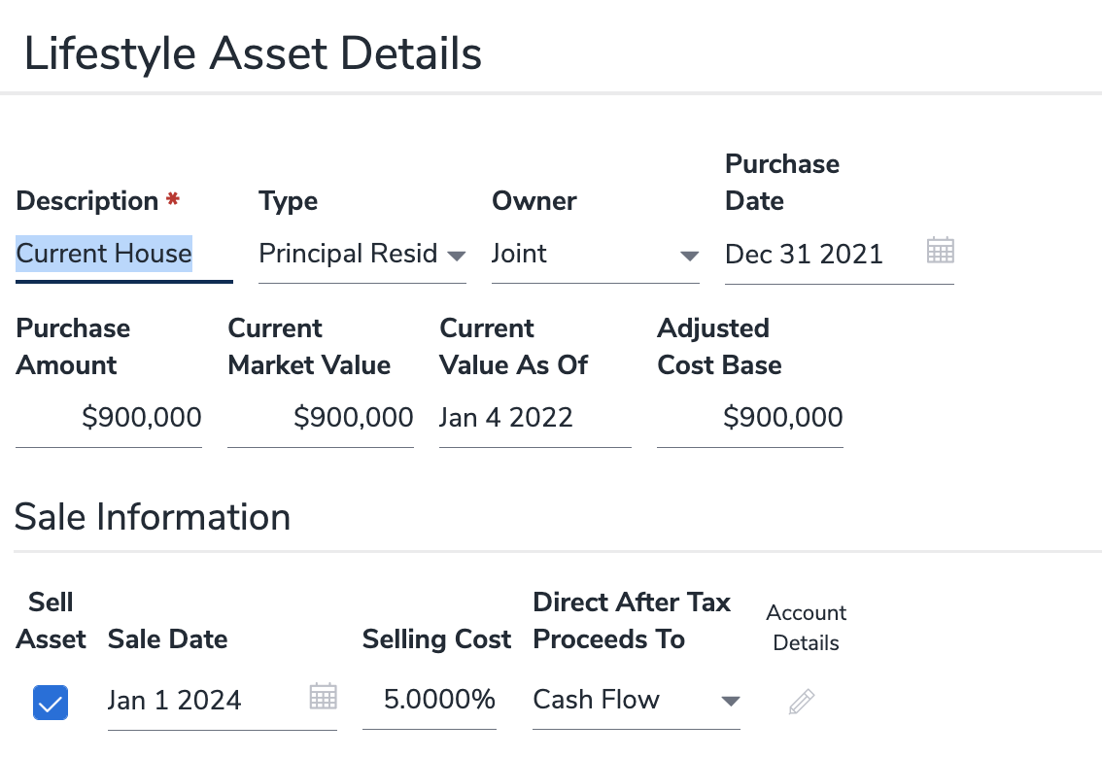
- We then need to determine what their net amount received is when factoring in your mortgage payoff and your real estate commission.
- Under Quick Actions, select Detailed Cash Flow - 2024. You will see Real Property Liquidations under Lifestyle Cost Base - $936,360 (note the inflation factor) and the real estate commission will be under Investment Expenses/Withdrawal Charge - $46,818.

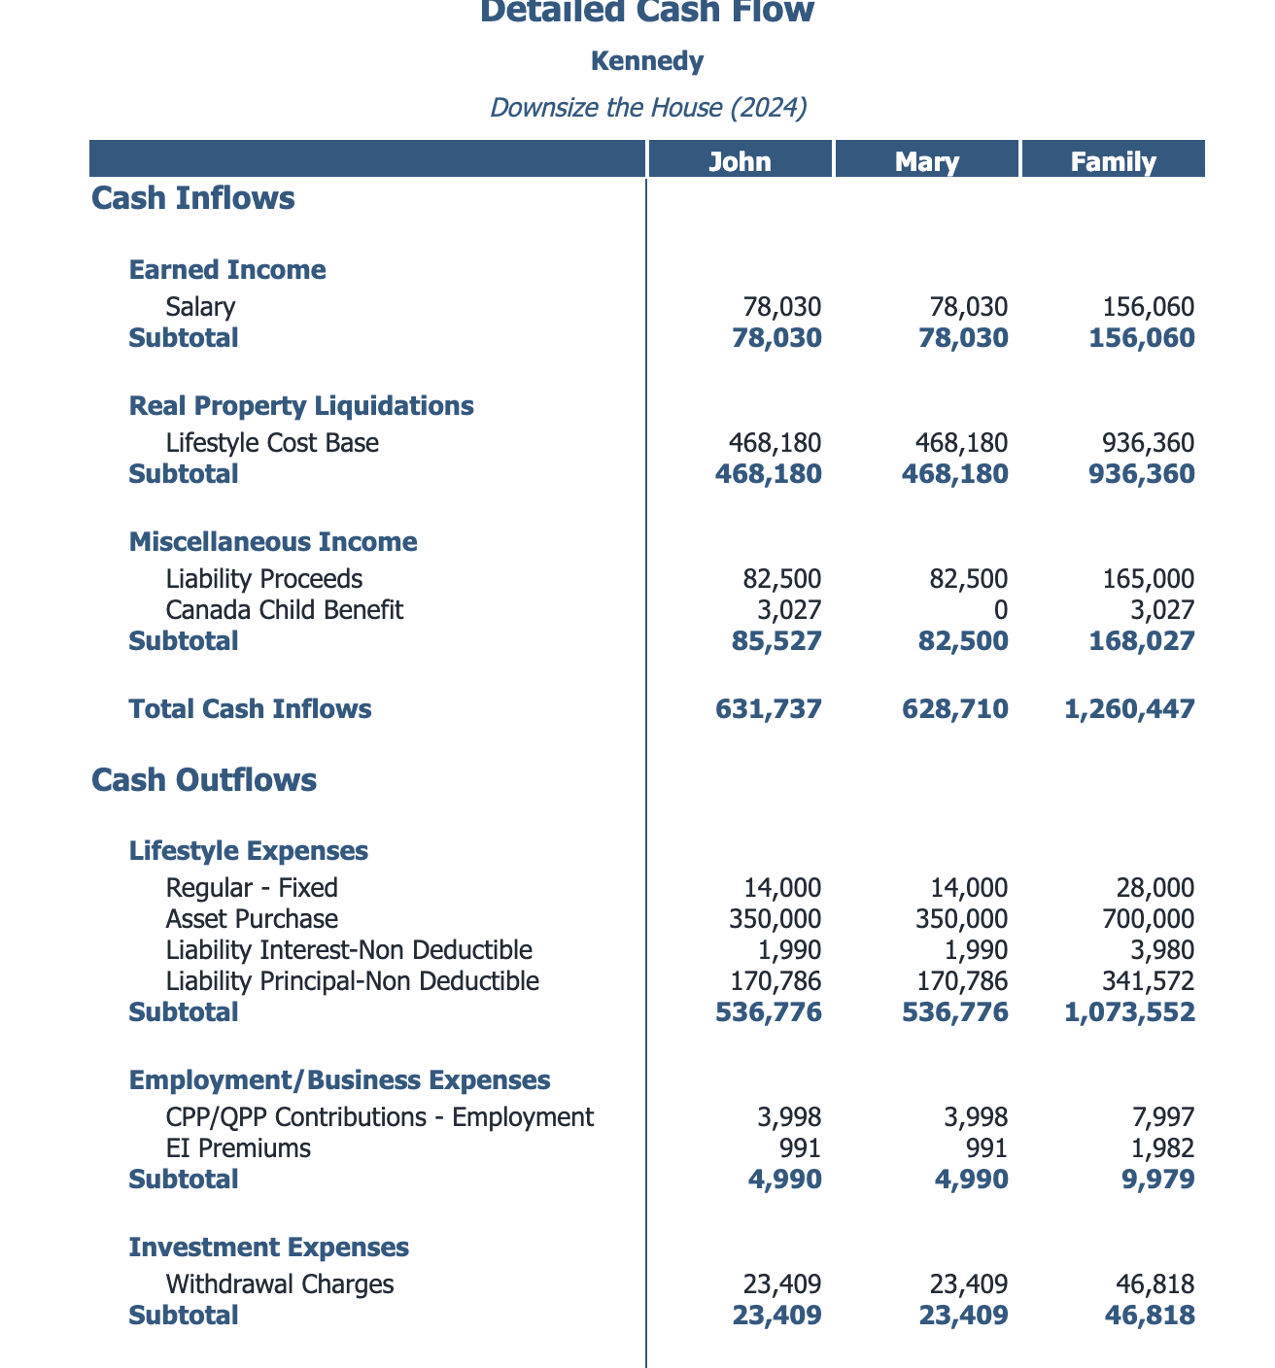

- In order to determine the mortgage payout, go to Quick Actions, select Reports - Net Worth - Liabilities - Liability Schedule. As the mortgage is paid off in 2024, select the Liability of Mortgage on House and use 3 years to display. The mortgage liability in January of 2024 is $327,515.82.

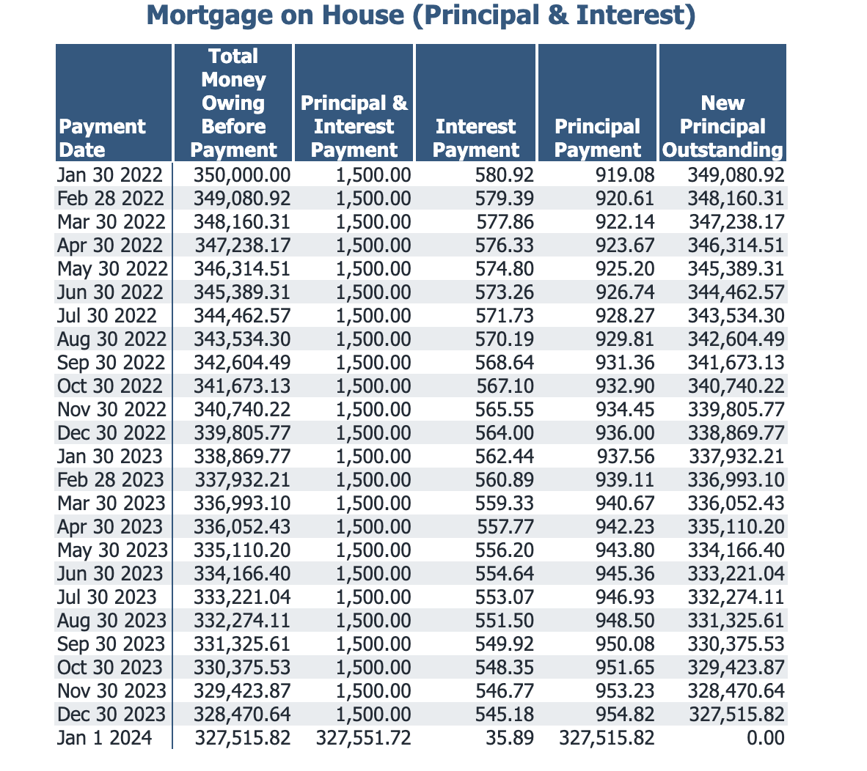
- The net house proceeds after inflation, less the real estate commission and the mortgage has been paid is as follows:
House Proceeds in 2024 | $936,360
Less Real Estate Fees | $46,818
Less Mortgage Payoff | $327,515
Net Proceeds from Sale of House | $562,026

- A condo will be purchased in January of 2024 for $700,000. For this translation go to Lifestyle Assets and purchase a Principal Residence for $700,000.

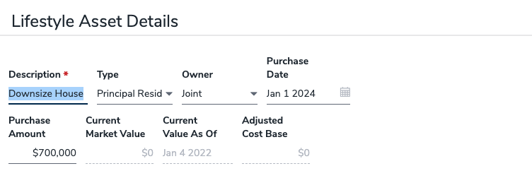
- Estimate Closing Costs. The land transfer tax in BC will be approximately $12,000 for a $700,000 condo. I have added an additional $16,000 to cover legal fees as well as potential condo renovations prior to moving in. Total closing costs including renos to condo - $28,000.

Net Proceeds from House | $562,026
Less New Condo Purchased | $700,000
Less Closing Costs | $28,000
New Mortgage Required (rounded) | $165,974

10. A new mortgage is required for approximately $166,000. You can enter under Liability Details. Note, link this to a new asset, use the date of the purchase of the house and ALWAYS bring this amount into cash flow under Renegotiable. The amortization should be close to coincide with their retirement date.
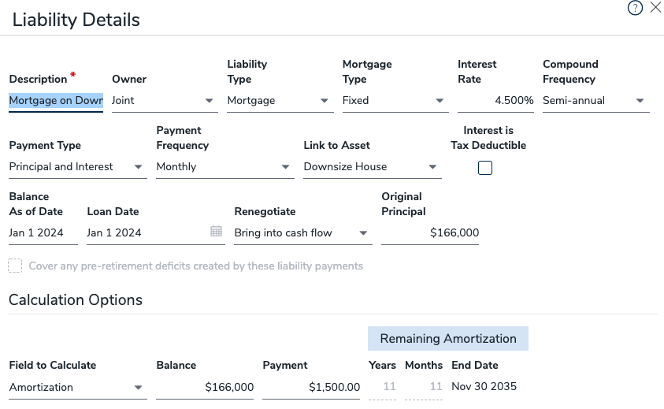
Now that they want to downsize their home, your members can find a solution. With a smaller or no mortgage payment, there could be a significant change in the retirement plan!!

Good Luck!!!!

Sheldon Craig, CFP®
Regional Manager
scraig@cuwealth.ca
CUSO Wealth Strategies Inc.

