Our Annual Strategic Plan

A simple guide to plan for success.

Completed by:
Completed on:

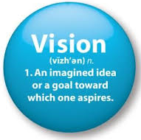
OUR VISION

Everything we do should tie directly back to the achievement of our vision.

Our vision is to…Click and type

OUR BELIEFS

Everything we do will be carried out in accordance with our core values and beliefs.

Here are a list of the things we believe are important when carrying out our vision:

OUR TEAM

Here are the individuals who will help us achieve our vision:

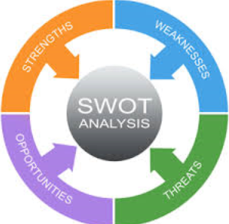
STRATEGIC ANALYSIS

Carefully consider our current situation, the industry environment, and other important factors in the environment to identify the following:

Strengths

Weaknesses

Opportunities

Threats

BUSINESS DEVELOPMENT - INTERNAL

Client Analysis

Review our Client Classification and update if and where required.
Ensure all Clients are coded accurately on our CRM.
Update our Client Analysis Worksheet.
Identify how many more or less of each client type we want to see by year end.
Review the referrals received last year and look for where we expect them to come from this year.

Goals:

Client Experience

Review our Client Service Model and fine-tune or update accordingly.
Order items required to execute our client service (i.e. cards, gifts, newsletters, etc.)
Review our Client FORM Profiles (family, recreation, occupation, interests) for our best clients.
Discuss strategy to acknowledge one Moment of Truth this year for each top client.

Goals:

Client Onboarding

Review our New Client Onboarding Process and fine-tune or update accordingly.
Order items required to execute our onboarding (i.e. cards, binders, gifts, etc.)

Goals:

Client Rebranding

Assess how many of our clients have been effectively rebranded.

Goals:

Branding

Review and update our Introduction Kit.
Review and update our Website.
Check for consistency on our Email Signatures.
Check for consistency on all other client-facing items (Agendas, Letters, etc.) using our Branding Standards.

Goals:

Office Operations

Consider ways to improve the operations for our team and clients.

Goals:

Office Environment

Consider ways to improve the office environment for our team and clients (new furniture, office renovations, moving spaces, etc.).

Goals:

BUSINESS DEVELOPMENT - EXTERNAL

Professional Network – Your Strategic Alliances

Review and update those identified and coded as our Strategic Alliances.
Review our Strategic Alliance Service Model and fine-tune or update accordingly.
Ensure our Strategic Alliance Service Model is fully automated by CRM.
Review our Client Profiles (family, recreation, interests) for each of our Strategic Allies.

Goals:

Professional Network - Others

Review and update our LinkedIn Profile.
Identify activities related to LinkedIn to further connections which are consistent with our brand.
Leverage our other Personal Associations & Networks to attract new clients.

Goals:

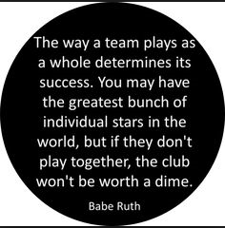
OUR TEAM

Team Structure & Training

Ensure each team member has an up-to-date Job Description.
Identify training needs of individuals and/or the entire team.

Goals:

Team Communication

Continue with Weekly Team Meetings.
Conduct the Quarterly Strategic Meetings with the entire team.
Conduct the Annual Team Building & Review session with the entire team.

Goals:

CRM Integration

Assess level of CRM access and integration by the team.
Identify if team training or system upgrades is required.

Goals:

OUR PROFITABILITY ANALYSIS

Current Target
Investment Revenue Fixed (Fee-based, Annuitized) $ $
Investment Revenue Variable (Other) $ $
Insurance Revenue $ $
Other Revenue $ $

TOTAL REVENUE $ $

Current Target
HR - Fixed Cost (Compensation & Benefits) $ $
HR - Variable Cost (Bonus & Incentives) $ $
HR - Training & Education $ $
Marketing – Branding (Stationary, Folders, Cards) $ $
Marketing – Gifts, Cards & Events for clients $ $
Marketing – Newsletters, Sponsorships, etc. $ $
Marketing – Website $ $
Technology - Hardware (PCs, Printers, etc.) $ $
Technology - Software (Programs & Subscriptions) $ $
Compliance & Licensing $ $
Courier & Postage $ $
Office Supplies $ $
Other $ $

TOTAL EXPENSES $ $

TOTAL PROJECTED PROFITABILITY $ $

OTHER THOUGHTS & IDEAS

