 | Annual Social Media Checklist
 | Your Preferred Social Media Platforms Identified
  - Your Website – Required
  - LinkedIn Profile - Strongly Recommended
  - Facebook
  - Twitter
  - Instagram
 | Website
- Annual Review of Static Information
  - Update content where required
  - Check pages and links
- Quarterly Review of Dynamic Information
 | LinkedIn
- Annual Review of Your LinkedIn Profile
- Annual Updating of your LinkedIn Contacts
- Determine Preferred Posting Frequency
- Set reminders in Maximizer to stay on track
- Post timely things you want to share throughout the year
 | Facebook
- Annual Review of Your Facebook Page
- Annual Updating of your Facebook Connections
- Determine Preferred Posting Frequency
- Set reminders in Maximizer to stay on track
- Post timely things you want to share throughout the year
 | Twitter
- Annual Review of Your Twitter Account
- Annual Updating of your Twitter Followers
- Determine Preferred Posting Frequency
- Set reminders in Maximizer to stay on track
- Post timely things you want to share throughout the year
 | Instagram
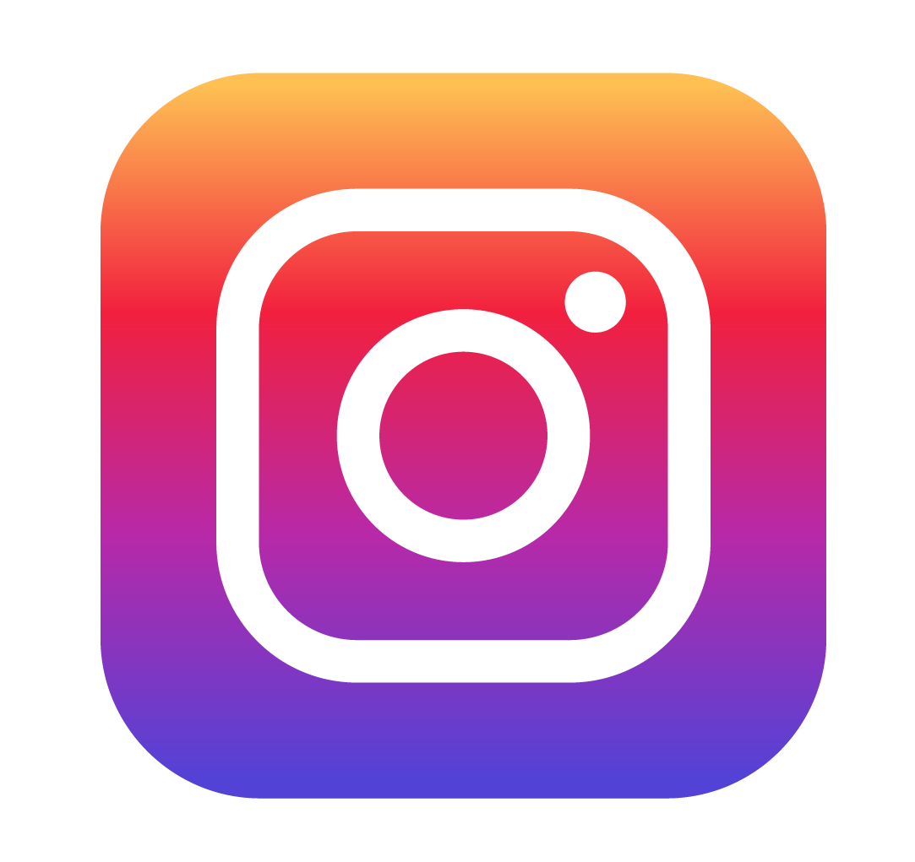 | - Annual Review of Your Instagram Profile  - Annual Updating of your Instagram Relations  - Determine Preferred Posting Frequency  - Set reminders in Maximizer to stay on track  - Post timely things you want to share throughout the year

