Navi (InvestCloud) Quick Action Reports

There is an excellent report feature in Navi that you can use as a guide to your analysis. It is called Quick Actions, and this can be located in the top right-hand side of the page. Note, this is not to be confused with the Client Report Navi Tip. This icon has multiple uses namely:

- It is an excellent tool for verifying the numbers you create.
- The reports can be used as part of your presentation.
- There are many strategies you can create such as displaying the tax credits for your members.
- The more common reports that you access can be saved under “Favorites”.

You can have your ‘Favorite Reports’ that you can share. When you access the reports, you will be given the option to Add to Favorites. Click on “Add To Favorites” for the reports as follows:

- Detailed Cash Flow
- Tax Credits
- Income Tax Details
- Asset Accumulation and Redemption
- Education Savings Report
- Itemized Cash Flow Projection
- Liability Schedule

To access the reports, use the following steps.

Click on the Quick Action Icon on the top right side of the page. Note, you must be in the plan option of your plan for Navi to access your numbers.

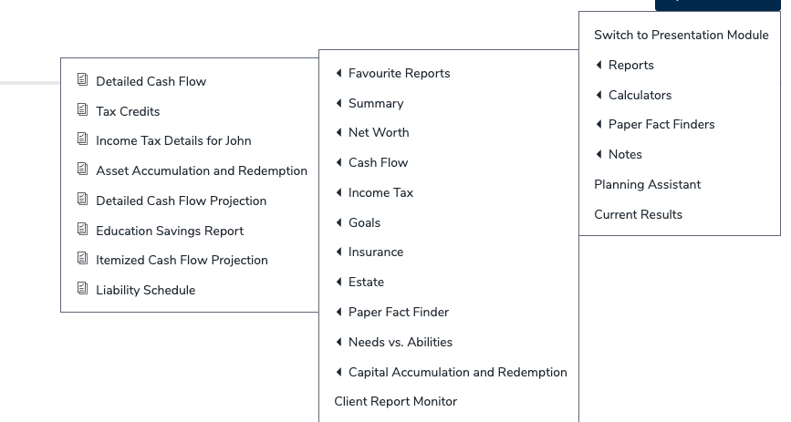

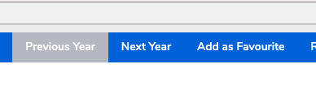

- Detailed Cash Flow Report

This report is only for specific calendar years and provides specific information on the income, expenses, and tax information. This report can be found in the Cash Flow Section of the Quick Action Tab.

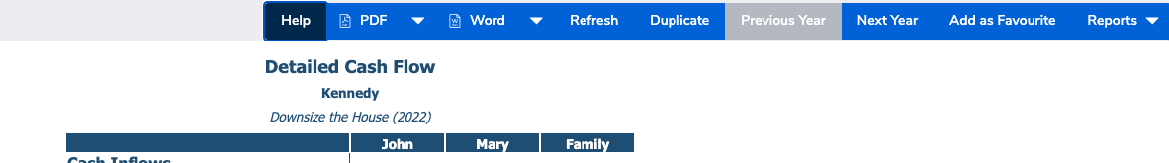

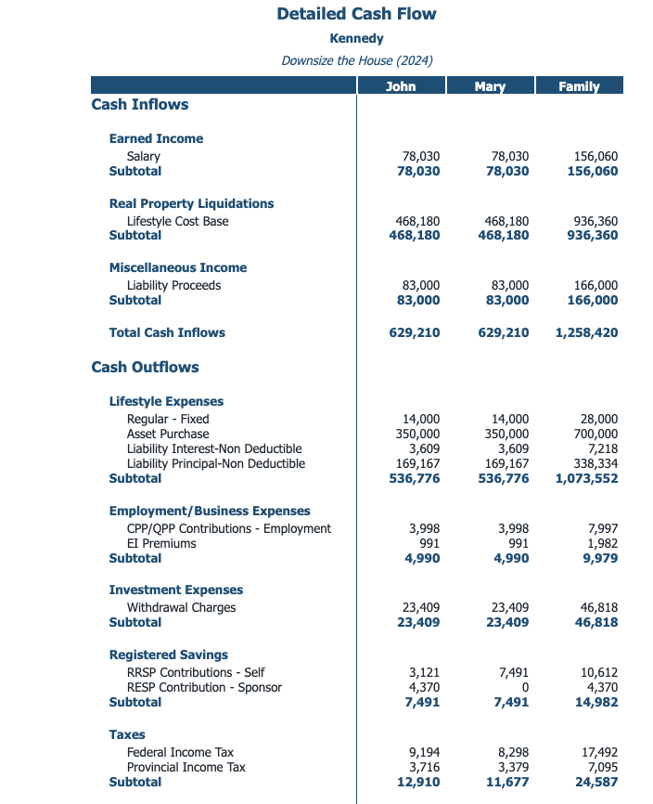

- Tax Credits

This report is valuable as it will show your Age Credit and the Pension Tax Credit. It will also show Charitable Gifting Credits (federal). For provincial tax credits, you need to access the Individual Tax Report page as well.

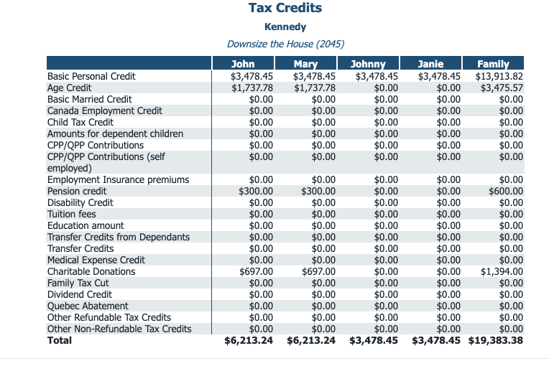

- Income Tax Details

This report will have specific information pertaining to the income tax payable and how the calculations were derived. This can be found under Reports, Income Tax, Income Tax Detail, and Income Tax Details for the specific member. Remember once you access the report, click on Add to Favorites.

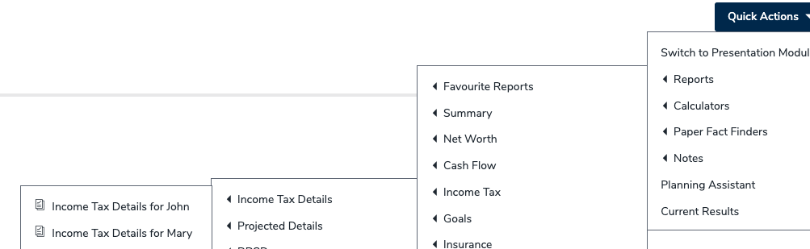

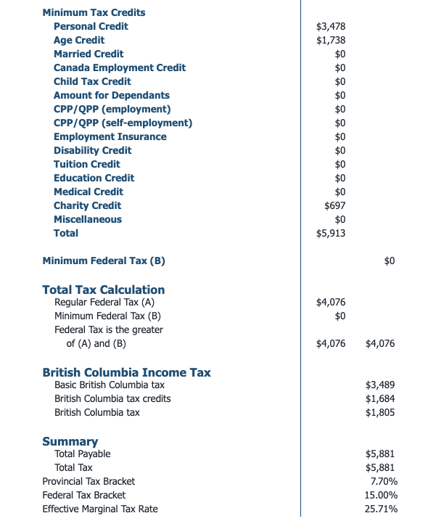

- Asset Accumulation and Redemption

This report is the one you can use when you need to see the remaining assets in a specific year. For example, if the client’s registered assets have been depleted, you can see what year they were depleted and start the next course of action. It is also great for using the Major Purchase Strategy. If your member is saving for a car or a vacation, you can access this report to see when their projected savings will be met, and you can create a plan for any shortfalls or surplus amounts. To access this report, click on Quick Actions, Reports, Capital Accumulation and Depletion and Asset Accumulation and Redemption. In this example you can see the sale of Kennedy’s home in 2024 as well as the purchase of the new condo.

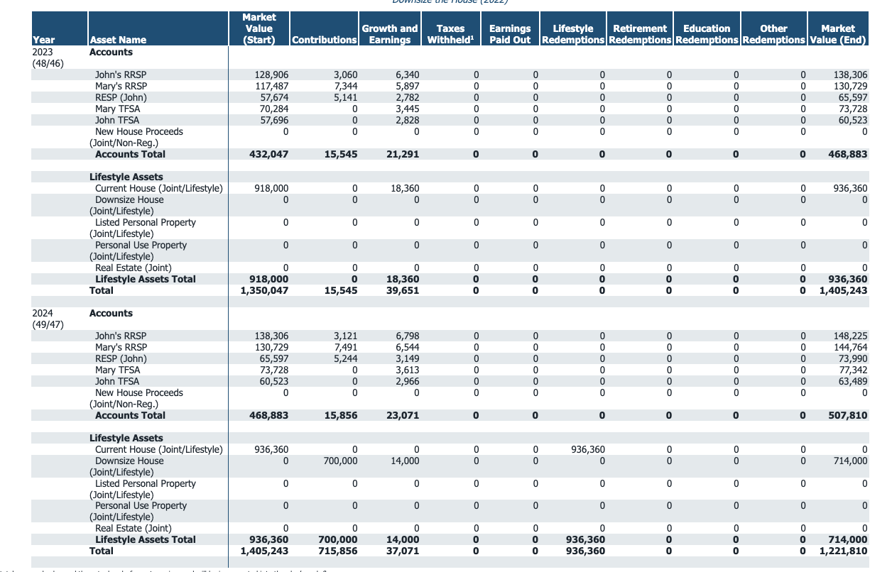
- Education Savings Report

This report itemizes the savings, the growth, CESG contributions as well as the EAP payments when the beneficiaries require the funding for post-secondary education. It is an excellent summary of the cost of education vs. the current savings strategy and will identify any expected shortfalls. This report can be located by clicking on Quick Actions, Goals, Savings and Education Savings Report. Remember to click on Add to Favorites when you access the report.

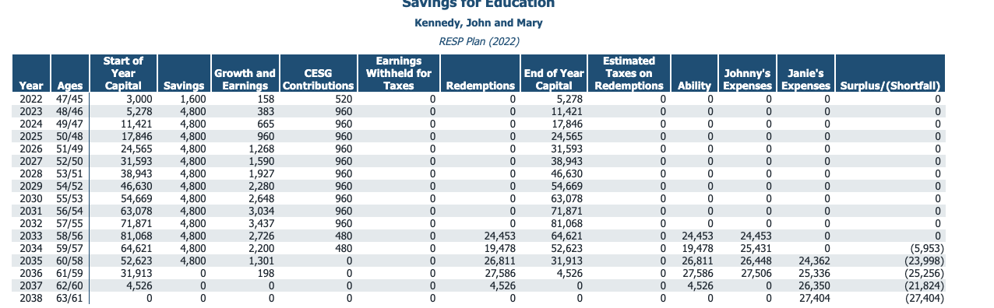

- Itemized Cash Flow Projection

This report is the one you can use the most when you want to review long term projections. It is valuable as you can view up to 10 years of cash flow. For your retirement projections, you will be able to view the registered draw based on other income and expenses. For example, when CPP and OAS commence, the draw from registered assets will decrease accordingly. This report can be located by clicking on Quick Actions, Cash Flow, Itemized Cash Flow Projection. Once you have the report accessed, click on Add to Favorites.

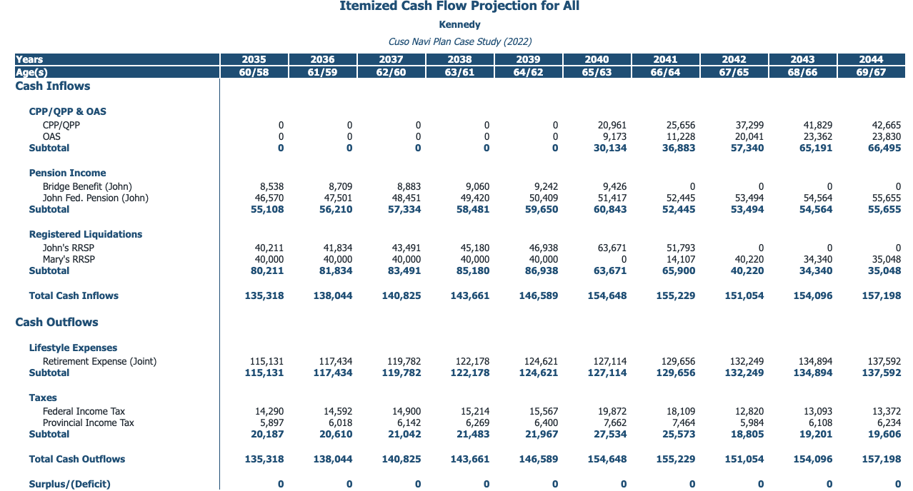
- Liability Schedule

This report will show the liability schedule for all your client’s loans and mortgages. When you are modifying a mortgage payment or paying a home off from a sale or an inheritance, you will be able to determine the payout amount from this report. In this example, the Kennedy’s were selling their house and the report was accessed to determine the mortgage payout on the date of sale. This report can be located by clicking on Quick Actions, Net Worth, Liabilities, Liability Schedule

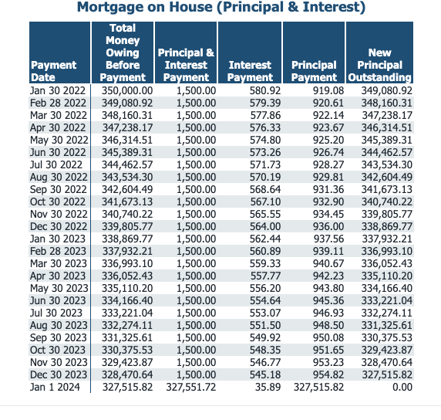

There are many other helpful reports available in the Quick Action Section. The quick action tab is an excellent tool for verifying information as well presenting specific information to your clients. Feel free to check out the many other reports available in this area!

Good luck and happy planning!!!!!

Sheldon Craig, CFP®
Regional Manager
scraig@cuwealth.ca
CUSO Wealth Strategies Inc.

