Registered Disability Savings Plan

A Registered Disability Savings Plan (RDSP) is a savings plan in Canada designed to help people with disabilities and their families save for the future. The Canadian government provides grants and bonds to help people with disabilities save for their future needs.

The money saved in an RDSP is tax-free until it is withdrawn.Contributions to the plan are not tax deductible. The plan is intended to provide financial security for individuals with disabilities and their families.

To be eligible for an RDSP, a person must meet the following qualifications:

- Canadian residency: The individual must be a Canadian resident with a Social Insurance Number (SIN).
- Disability: The individual must be eligible for the Disability Tax Credit (DTC) and have a valid certification of their DTC eligibility from the Canada Revenue Agency (CRA).
- Age: The member must be under 60 years of age. The last year to contribute is the calendar year of age 49.

It's important to note that a person can only have one RDSP and the plan must be opened by the individual or their legal representative. Regular withdrawals must begin in the calendar year the member turns 60 years old.

Note - Members may ask us specific questions regarding qualifying for the Disability Tax Credit (DTC) and it is imperative that this question be directed to the family doctor.

Grants and Bonds

The plan can receive grants and bonds from the Canadian government, which are contributions made to the plan to help individuals with disabilities save for their future. These grants and bonds are designed to encourage and support savings for individuals with disabilities, and they can be a significant source of funding for RDSPs.

The amount of the grants offered under the Registered Disability Savings Plan (RDSP) in Canada depends on several factors, including the individual's family income and the amount contributed to the plan. There are two types of grants offered under the RDSP: the Canada Disability Savings Grant (CDSG) and the Canada Disability Savings Bond (CDSB).

The CDSG provides a matching contribution of up to 300% on contributions made to the RDSP, with a maximum annual grant of $3,500 and a lifetime limit of $70,000. The amount of the grant depends on the individual's family income and the amount contributed to the plan.

The CDSB is a non-contributory grant that provides up to $1,000 per year to individuals with a low family income and a maximum lifetime limit of $20,000.

RDSP Strategies

- For beneficiaries with a family income below $98,040, the CDSG provides a matching rate of 300% on the first $500 and up to 200% on the next $1,000 contributed annually.
- For beneficiaries with a family income between $98,040 and $110,529 the CDSG matching rate is 100% on the first $1,000 contribution.
- For beneficiaries with a family income above $110,529, no CDSG matching contributions are available.
- You can carry-forward grant and bond amounts from past years. The amounts of grant and bond that the member was eligible to receive from past years are still available in the current year! The maximum grant for catch up purposes is $10,500 per year; therefore, the maximum annual contribution is $4,500 per year.

For example, in one year you can receive as much as $10,500 in RDSP Grants assuming the RDSP Beneficiary is eligible. If your member had the available grant room and contributed $1,500 in Quarter 1, another $1,500 in Quarter 2 and an additional $1,500 in Quarter 3, the total grant would be $10,500.

Catch up on Past Grants | Contributions | First $500 | $2 grant for $1 contributed | Total Grant
Quarter 1 | $1,500 | $1,500 | $2,000 | $3,500
Quarter 2 | $1,500 | $1,500 | $2,000 | $3,500
Quarter 3 | $1,500 | $1,500 | $2,000 | $3,500
Totals | $4,500 | $4,500 | $6,000 | $10,500

RDSP Potential Terminations

- Death of the beneficiary: If the beneficiary of the RDSP passes away, the plan will be terminated, and the funds will be distributed to the beneficiary's estate.
- Loss of eligibility: If the beneficiary no longer qualifies for the Disability Tax Credit (DTC), they will no longer be eligible for the RDSP. If this occurs, the plan will be terminated, and the funds will be distributed to the beneficiary.
- Plan maturity: The RDSP must be closed by the end of the year in which the beneficiary turns 60 years old. At this point, the funds must be paid out in the form of a lump-sum payment or transferred to a Registered Retirement Savings Plan (RRSP) or Registered Retirement Income Fund (RRIF).
- Plan revocation: The government may revoke an RDSP if the plan holder does not comply with the rules and regulations surrounding the plan.

It's essential to note that the termination of an RDSP may have tax consequences, and it's always a good idea to consult with a financial advisor or tax professional before taking any actions that may affect your RDSP.

Note, for the terminations, if the RDSP has been in existence for a period of 10 years or longer, there are special considerations made.

How to enter an RDSP in NaviPlan

Navi doesn't have an RDSP program in its system however the following steps will create the same result.

- Under Accounts Enter the RDSP Plan under Group RRSP. Under the savings strategy, enter the owner contribution and the employer contribution will represent the government grants. For example, a $1,500 annual contribution will trigger $3,500 in government grants (assuming income qualification and other criteria are met). You would enter $1,500 as owner contribution and $3,500 as Employer Contribution.

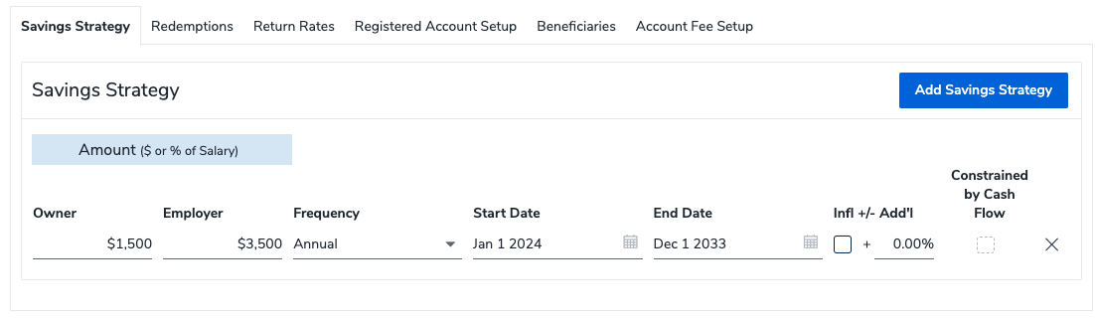

- You will need to generate an offsetting tax entry as RDSPs are not tax deductible. To do this, enter RDSP Income as other income. In this example, $1,500 is entered as Other Taxable Income.

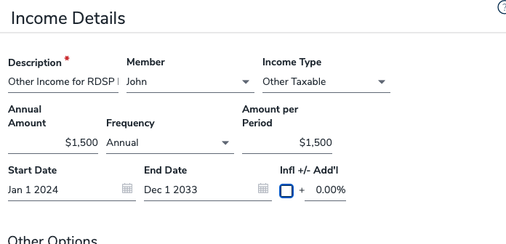

- You will need to offset this entry by entering an expense of $1,500 under the expense Tab. I called this an RDSP Expense offset under the expense tab. For this example, enter $1,500 in my expenses.
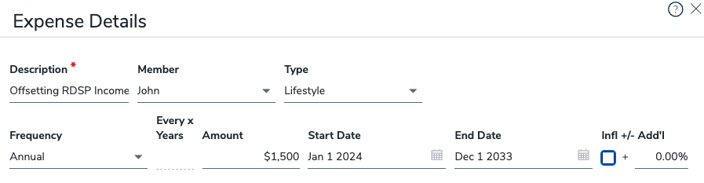

- The entries can be a one-time or recurring entries depending on your strategies.
- When calculating the income distribution, the grants and yield will be taxable to the beneficiary, however, the original contribution is not taxable. You can manually adjust the tax deductions under tax details by the amount of the original contribution. I would recommend this be completed closer to the time of withdrawals.

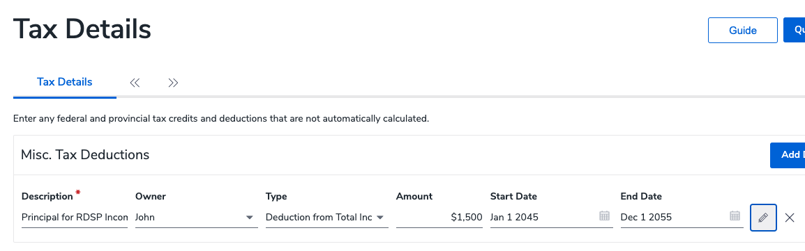

Summary

You can make a HUGE difference in the lives of your members' financial well-being by discussing the RDSP program to those who may qualify. The RDSP program is not well advertised by the Canadian Government, therefore knowing your members you may discover they have a child that has a form of disability, and they may qualify for the Disability Tax Credit and subsequently the Registered Disability Savings Plan.

Sheldon Craig, CFP®
Regional Manager
scraig@cuwealth.ca
CUSO Wealth Strategies Inc.

