Effective Integration of Your CRM
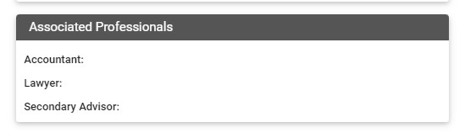
Readily identifying the various professionals working with your top clients is important and you can use the following fields on the Details Tab of the Household Record:

Tracking and managing the relationships of Strategic Partners on your CRM is highly recommended.
Feel free to use the Action Plan built on Maximizer which provides quarterly reminders for touchpoints with these important relationships. In addition, be sure to include them with your Thanksgiving Cards as well as, looking for opportunities to acknowledge Moments of Truth (which are also tracked in the CRM).
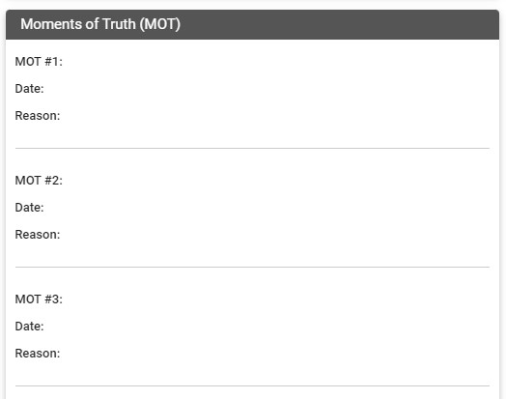

Of course, we recognize you may want to customize the standardized Action Plan for servicing your Strategic Partners based on who they are and what they do – which can impact time of year and specific activities you want to integrate. We encourage you to do so by modifying the description and timing of tasks as well as, adding others once it has been launched in the Strategic Partner contact record.
What are some of the Action Items you need to take to develop full integration so you can track this thoroughly?
__________________________________________________________________
__________________________________________________________________
__________________________________________________________________
__________________________________________________________________

