YOUR PERSONAL FINANCIAL ORGANIZER

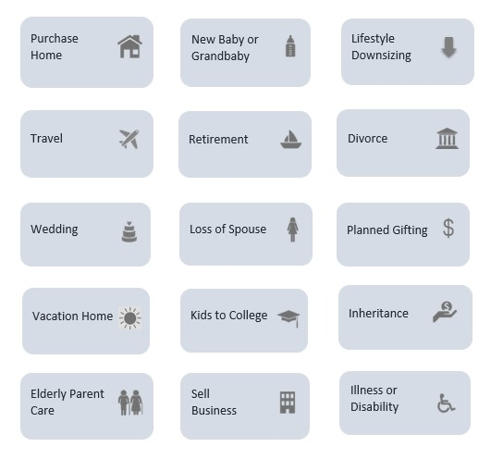

Helping You Manage Your Significant Life Events

CLIENT NAME
DATE

  DAILY LIVING  Allowing you to focus on enjoying life day by day | Date Last Reviewed

  CURRENT SAVINGS  Managing your money to help you achieve all of your goal | Date Last Reviewed

  TO AND THROUGH RETIREMENT  Guiding you to & through retirement | Date Last Reviewed

  CARING FOR OTHERS  Taking care of those who depend on you | Date Last Reviewed

  TAX PLANNING STRATEGY  Helping you keep more of your money | Date Last Reviewed

  FAMILY SECURITY  Providing security & comport to you and your family | Date Last Reviewed

  LEAVING YOUR LEGACY  Leave a legacy for the people and causes you care most about | Date Last Reviewed

  BUSINESS PLANNING & SUCCESSION  Allowing you to focus on enjoying life day by day | Date Last Reviewed

