Annual Strategic Plan

Team Workbook

A simple guide to plan for success.

Date

Our Vision, Beliefs & Team
Our VISION

Everything we do should tie directly back to the achievement of our vision.

Our vision is…

Our BELIEFS

Everything we do will be carried out in accordance with our core values and beliefs.

Our TEAM

Here are the individuals who will help us achieve our vision:

Recap & Review of Last Year

What we Achieved Last Year

Our Outcome-Based Results:

Total AUM $

Net New AUM $

Total Production $

Fee-Based Business %

Insurance Revenue %

Total Number of Relationships

Number of New Ideal Clients

Retention % of Ideal Clients

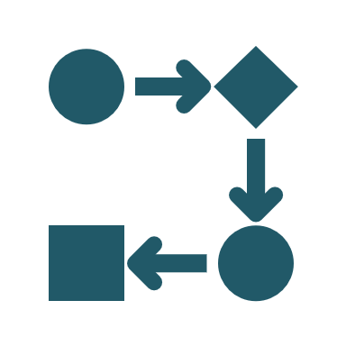
What We Completed Last Year

Our Activity-Based Results:

- Client Analysis
- Client Experience
- Client Onboarding
- Client Rebranding
- Marketing & Branding
- Investment Management
- Financial Planning
- Insurance Solutions
- Technology & CRM
- Operations
- Team Development
- Working with Strategic Partners
- Other

Strategic Analysis
Carefully consider our current situation, the industry environment, and other important factors in the environment to identify:

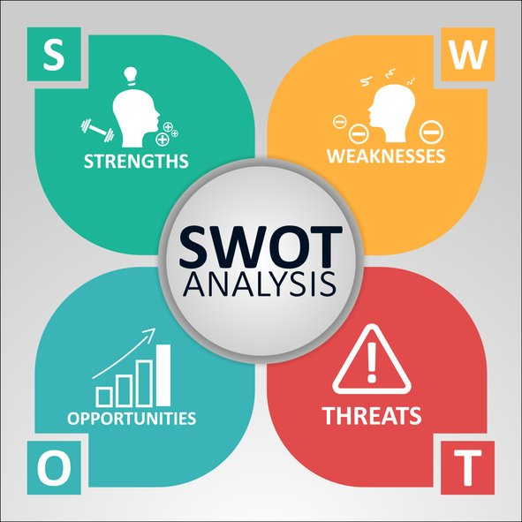
Define Our Goals for Next Year
What we Want to Achieve this Year

Our Outcome-Based Results:

Total AUM $

Net New AUM $

Total Production $

Fee-Based Business %

Insurance Revenue %

Total Number of Relationships

Number of New Ideal Clients

Retention % of Ideal Clients

What We Want to Complete This Year

Client Analysis Managed by: _________________________

Review our Client Classification and update where required
Update our Rightsizing Worksheet and discuss results
Identify goals related to number of clients, by type, for next year
Maintenance: Ensure all Clients are coded accurately on our CRM

Goals:

Client Experience Managed by: _________________________

Review our Client Service Model and fine-tune or update accordingly
Review our Client Profiles (family, recreation, occupation, interests) for our best clients
Discuss strategies to acknowledge one Moment of Truth this year for each top client
Maintenance: Order items to execute our client service (ie. cards, gifts, newsletters, etc.)
Maintenance: Continue to have the Client Experience fully automated on the CRM

Goals:

Client Onboarding Managed by: _________________________

Review our New Client Process and fine-tune or update accordingly
Maintenance: Order items required to execute our onboarding (i.e.. cards, binders, gifts, etc.)
Maintenance: Continue to have Client Onboarding fully automated on the CRM

Goals:

Client Rebranding Managed by: _________________________

Assess how many of our clients have been effectively rebranded and who is not yet completed
Discuss the results of the rebranding using the Rebranding Tracker

Goals:

Marketing & Branding Managed by: _________________________

Review and update our Introduction Kit
Review and update our Website
Review and update our LinkedIn Profile and/or other Social Media Platforms
Check for consistency on our Email Signatures & all other client-facing items

Goals:

Investment Process Managed by: _________________________

Investment Management Process Assessment & Discussion
Are we proactively managing our clients’ investment needs?
Continued shift to managed money and/or core portfolios
Continued shift to fee-based business
Implement a standardized approach to fee-based business
Enhance or add to our investment solutions where required

Goals:

Financial Planning Managed by: _________________________

Financial Planning Approach Assessment & Discussion
Are we proactively managing our client’s planning needs?
Are we using the right financial planning program?
Are we providing our clients with a meaningful financial plan?

Goals:

Insurance Solution Managed by: _________________________

Insurance Solutions/Risk Management Assessment & Discussion
Are we proactively managing our clients’ insurance needs?
Are we providing our clients with a meaningful financial plan?

Goals:

Technology & CRM Managed by: _________________________

Review our current IT systems (software) to assess necessary upgrades
Review our current IT technology (hardware) to assess necessary upgrades (i.e.. new PCs, printers, scanners, etc.)
Identify the CRM coordinator on the team
Assess level of CRM access and integration by the team
Identify what, if any, additional CRM customizations are required
Identify if team training or system upgrades are required

Goals:

Operations Managed by: _________________________

Identify the individual on the team responsible for coordinating & maintaining the Procedures Manual
Review our Procedures Manual to assess its effectiveness, and make changes as required
Consider ways to improve the operations for our team and clients
Consider ways to improve the office environment for our team and clients (new furniture, office renovations, moving spaces, etc.)

Goals:

Team Development Managed by: _________________________

Review Advisory Blueprint to assess effectiveness, and plan for changes as required
Ensure each team member has an up-to-date Job Description
Identify training needs of individuals and/or the entire team
Are the Weekly Team Meetings consistent and effective?
Are the Quarterly Strategic Meetings consistent and providing ongoing direction?
Are the Annual Strategic Planning Sessions defining a common vision, goals & action plan to achieve them?

Goals:

Strategic Partners Managed by: _________________________

Review and update those identified and coded as our Strategic Partners
Review our Strategic Partners Service Model and fine-tune or update accordingly
Ensure our Strategic Partners Service Model is fully automated by CRM
Review our Client Profiles (family, recreation, interests) for each of our Strategic Partners

Goals:

Other Thoughts & Ideas Managed by: _________________________

Buying a book of business to increase AUM and number of quality clients
Expanding the Team
Changing the type of relationship with our current firm or changing firms

Goals:

